Convolutional neural network (CNN) classifier for classifying dogs and cats. Data from Kaggle

Visualization of accuracy and loss

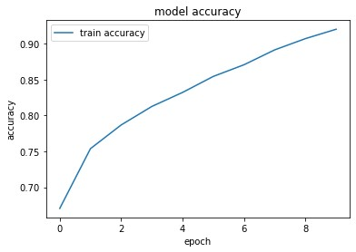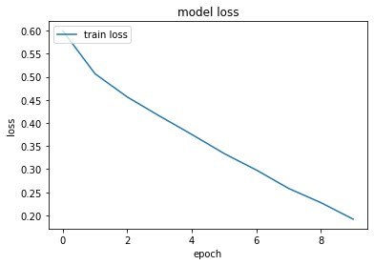

Visualization of misclassification

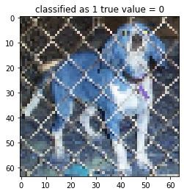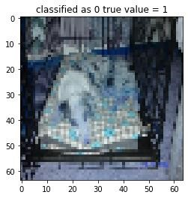

\*\*\* Okay so funny remark about this first misclassification picture. It is actually a dog and the model also classified is correctly as a dog but what happened is as you can see it is actually labeled as a cat in the dataset. So I went hunting for this dog in the cat folder of the pet images because I thought the model had some issues but I actually found this dog picture mixed up in the cat images folder. The original picture of the dog in the cats folder is given below and its name is 4085.jpg.

